**Classroom Activity: Write a code to create nested class components in ReactJS**

**Code:**

File Name: src/ App.js

import React, { Component } from 'react';

class App extends React.Component {

   render() {

      return (

         <div>

            <First/>

            <Second/>

         </div>

      );

   }

}

class First extends React.Component {

   render() {

      return (

         <div>

            <h1>EDUNET FOUNDATION</h1>

         </div>

      );

   }

}

class Second extends React.Component {

   render() {

      return (

         <div>

            <h1>Edunet Foundation</h1>

            <h2>https://edunetfoundation.org/</h2>

            <p>EMPOWERED. EQUIPPED. FUTURE-READY

            Get skilled, Get certified- Learn the best, from the best!</p>

         </div>

      );

   }

}

export default App;

**OUTPUT:**

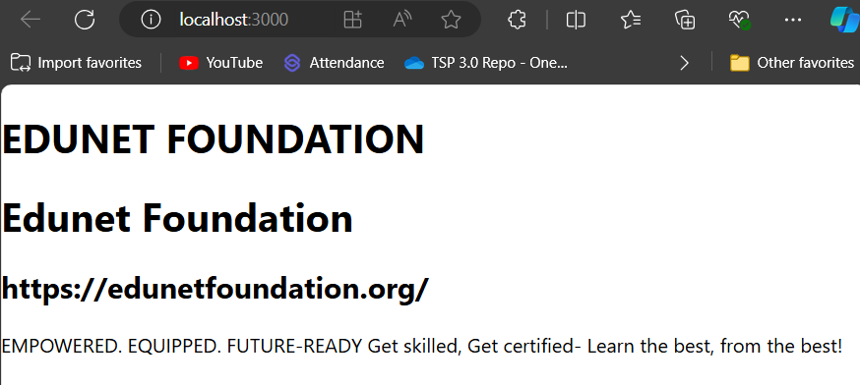

Figure: Output Screenshot

**Execution Steps:**

* Write the above code
* Go to VS Code terminal
* Execute following command to run the program: npm start
* This will open your default browser and navigate to http://localhost:3000, where you will see your new React application running.